Start here:

## General Info

* Response essentials and shortcuts: <https://sites.google.com/activesportsinc.com/cxhelpdesk/cheat-sheet>
* In shared DBA drive, troubleshooting queries can be found in R4W_Primary folder.
* Kai uses Kais_Queries > Audit for most things that regularly need to be checked & Kais_Queries > Reports for things that other departments often ask for.  
  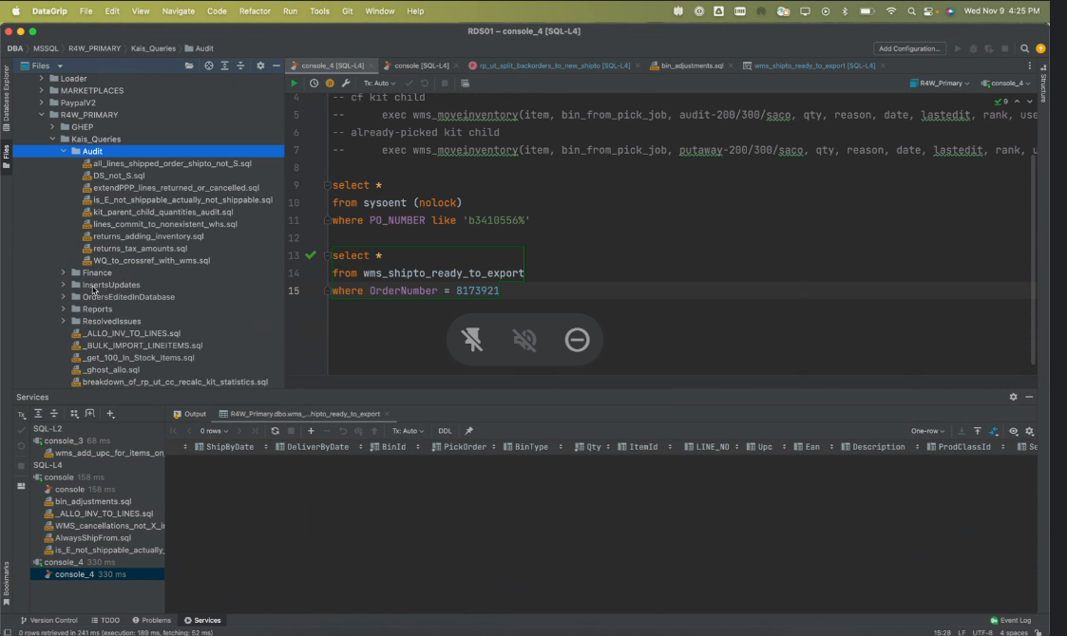

## 

## R4W Database Navigation

— section in progress —

## Order Not Importing to WMS

* Tab/Johnny on CS can generally fix these. There are a few other CS folks who also are good at troubleshooting this type of thing.
* **wms_shipto_ready_to_export** is the view in R4W_Primary that the WMS uses to get orders to import.

1. Check if the order exists in the view
   * select * from wms_shipto_ready_to_export where Ordernumber = ?
2. If no, run the order in the query found in **Kais_Queries > Audit > WQ_order_not_in_WMS.sql**
   * Checks all of the conditions that the wms view is looking for and returns y/n depending on whether the order passes or fails the check.
   * Allows you to know exactly what is “wrong” with the order
3. If something on the order needs to be edited, unpick the order
   * Unpick the order via WMS (even if order is not in wms)
     1. <https://wms.activesportsinc.com/Shipto/Unpick>
   * If we need to unpick many orders at once & **they are not in wms**…  
      Response: **V11 Highlights > Unpick Utility**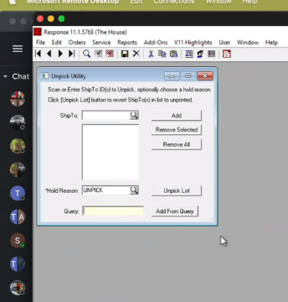
   * Can paste in shipto IDs one-by-one in the top ShipTo field or paste a query that returns only shipto IDs in the bottom Query field.

Query in R4W DB -

select * from sysoent(nolock) where Po_number

## E-status & Won’t Release/Print

Happens during a response release if the process were to get interrupted. Like a user got kicked out of response during a print. If the order has sugg_ship_qty and is “green”, this could sometimes be the reason preventing an order from print releasing (turning from E to W status).

* To find out which shiptos are in a batch, run this query:   
  **select** * **from** BATCHSEL (nolock) **where** batch = 20221114125649
* The batch number is the datetime as an int, so if the batch is very close to “now”, it could be in the process of being released for real. Check with the “Created By” user if you think there is an issue with the batch in this case.

1. Orders > Print/Reprint Pick Tickets > Select Batch (top left)  
   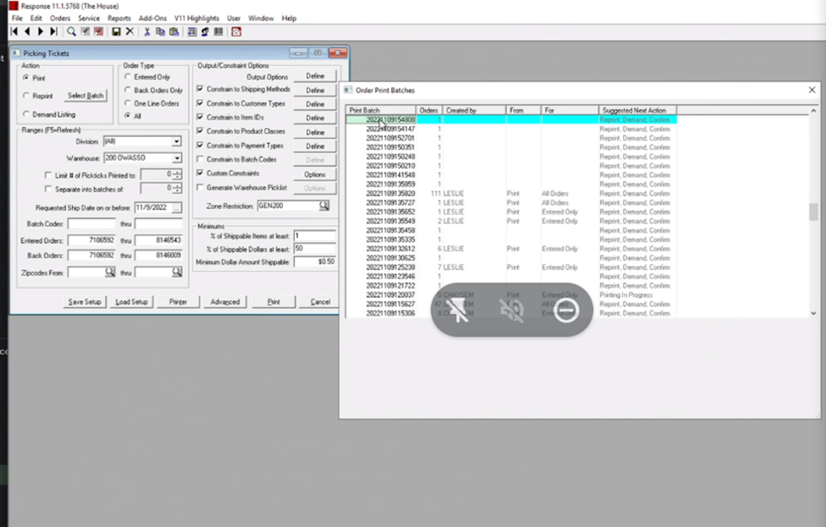
2. If there’s a batch that shows **Printing In Progress** in the Suggested Next Action column, continue to the next step. If not, the print is not the issue.
3. Click **Print** on the Order Print Batches window. When the popup comes up saying “Did Everything Print Correctly?, hit **Cancel** (not No)
4. These “stuck” orders will now release with the next batch

## Inv. Allo/Commit #s Out of Sync

Run only after hours, and importers need to be turned off. (This is a last-resort type of thing)

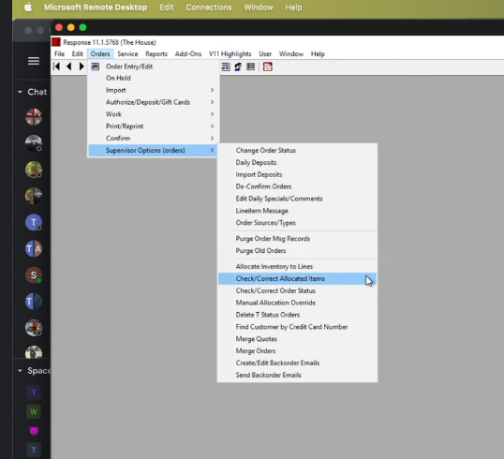

## Merge 2 Customer Profiles

Go to File>Supervisor Options>Merge/Purge Programs>Merge/Purge Known Duplicates  
Master will be the new ‘main’ customer id. Duplicate will merge into Master.

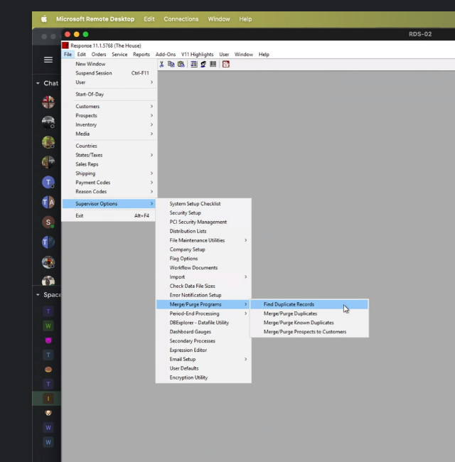

## 

## Order Not Imported into Resp.

RCK: information from website conversion into Response Order

Check in Quarantine/ inprogress if the order does not make it to Response.

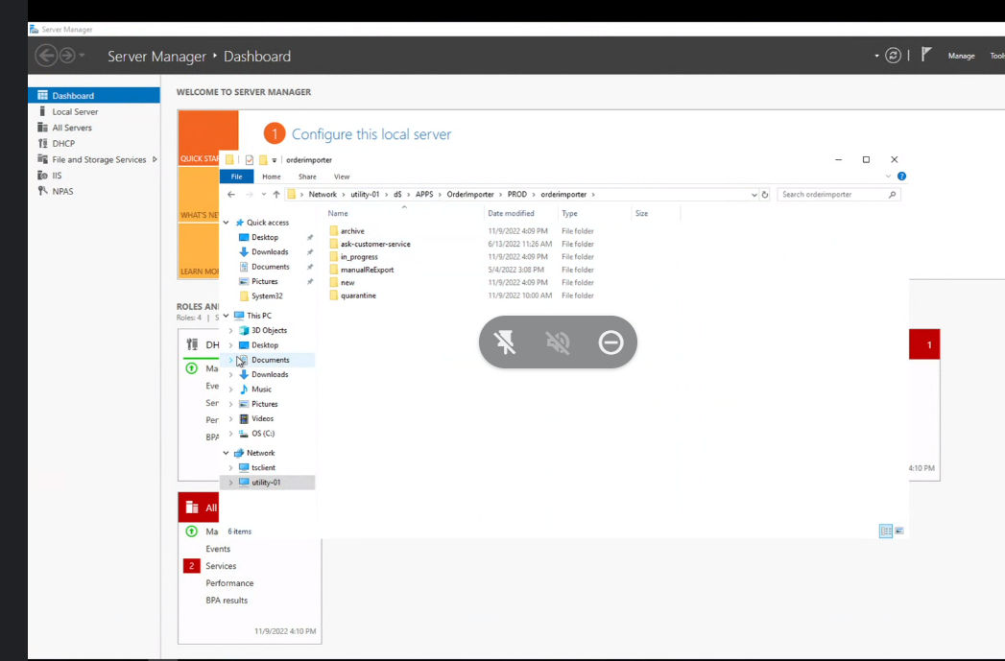

Flow for the below diagram- (What to look into) -Utility01- Order importers- R4w

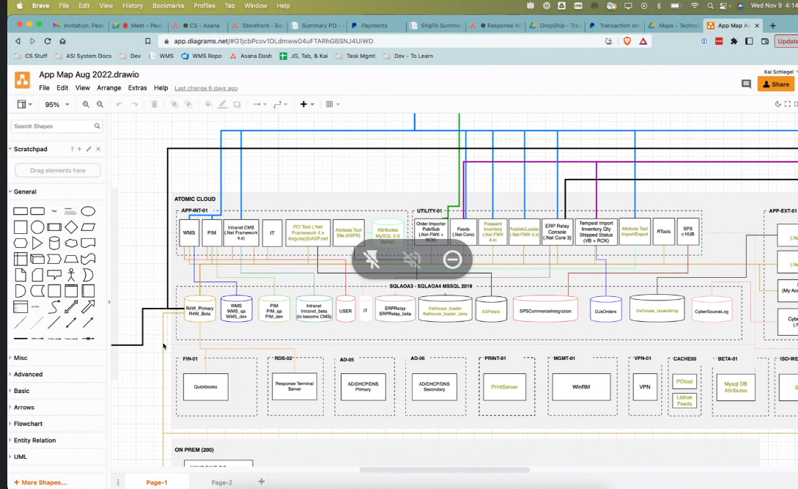

If you have windows, open up task scheduler on your local computer

Right click on Task Scheduler and click Connect to Another Computer…

Type in the name of the server that you want to connect to. In this case, that would be UTILITY-01. Then, click ok

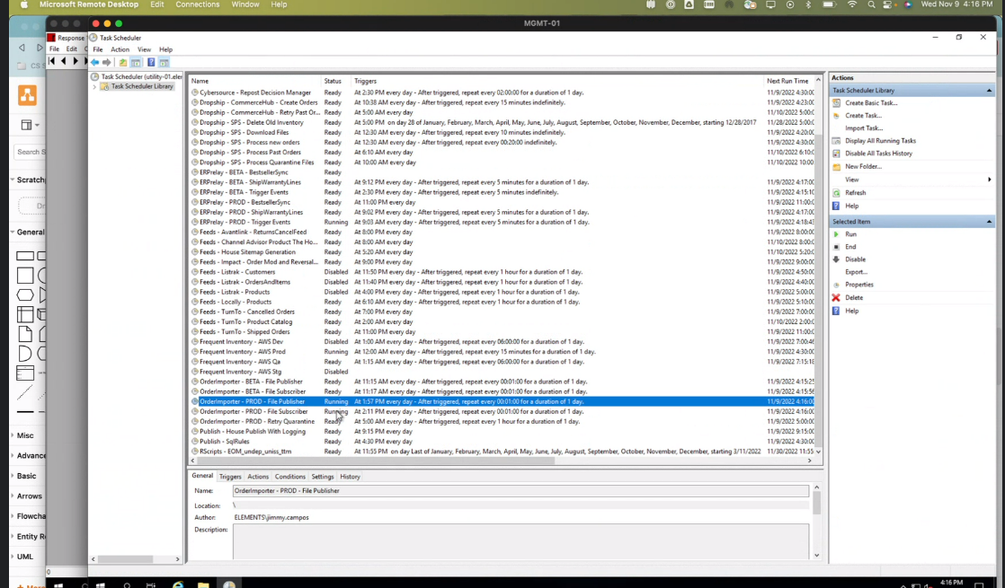

## W in Resp. & Exported in WMS

Check MIMPORT table.- in R4W

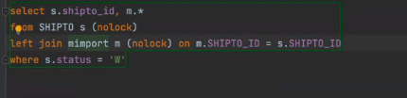

WMS DBQuery-

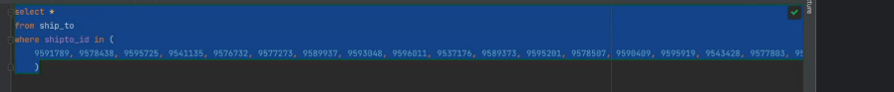

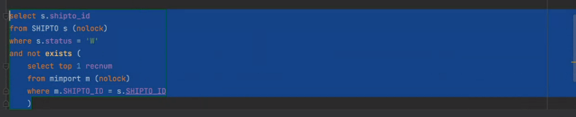

Solution:

a. Take the SQLtext from the Export_audit table/ modify syntax if needed and run them to create MIMPORT record.

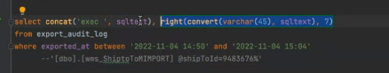

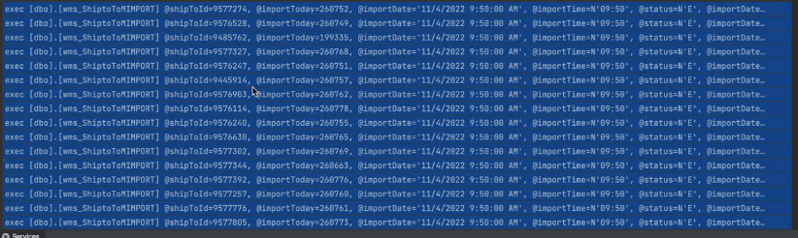

b. Run the confirmation process in response.

## 

## All lines S but order/shipto not S

**IMPORTANT: this is equivalent to changing the sysoent.order_status directly in the database.**

Only use as the **last resort** for fixing order statuses!

| Line status | All S | Qty 1 or more = W/Q |
| --- | --- | --- |
| Shipto status | <> S | <> W, <> Q |
| Order status | <> S | Not relevant |
| Why this happens | The very last item on the order was removed after all other items on the order had already shipped. | Unpicking sets order status to H, but orders can’t confirm when they’re H, so sometimes things get out of sync. |
| Bug or user error? | Response bug | Unpicking bug |
| Purpose of changing | Fix incorrect status for reporting purposes | Be able to unpick the order/lines on the order |
| Change status to this | S | Q |

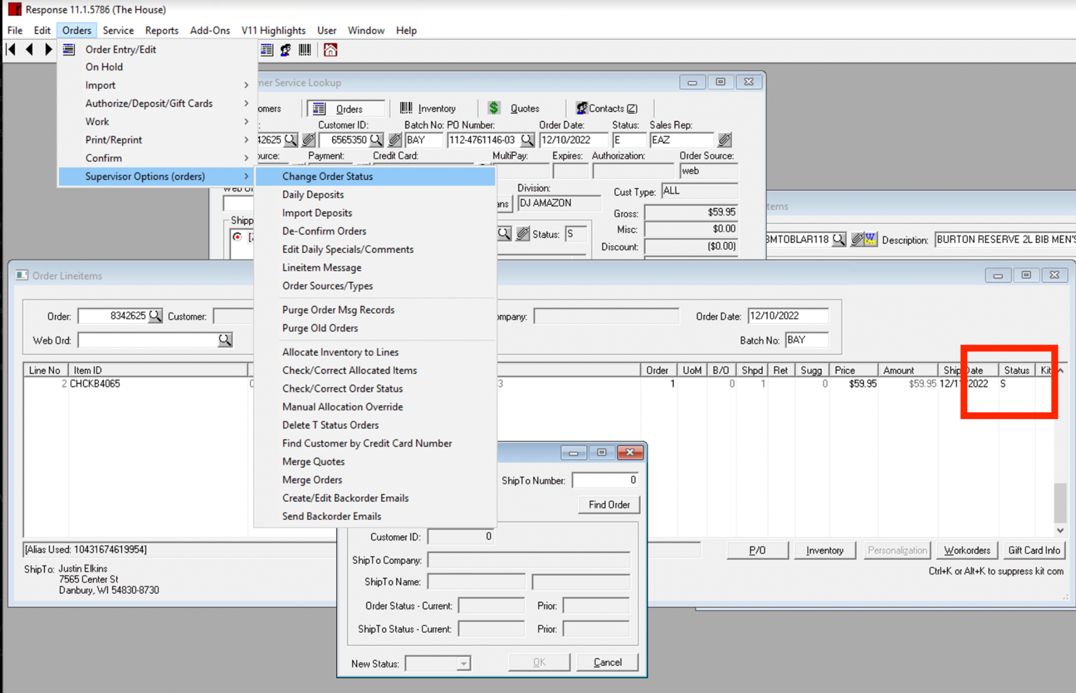

1. Make sure ALL lines on whole order are S status

* If the shipto is not S, we also could reprint and then confirm by shipto ID (if no other confirms or manifest confirms are running). As long as we’re sure all lines are S, it’s easier to just manually change the order status.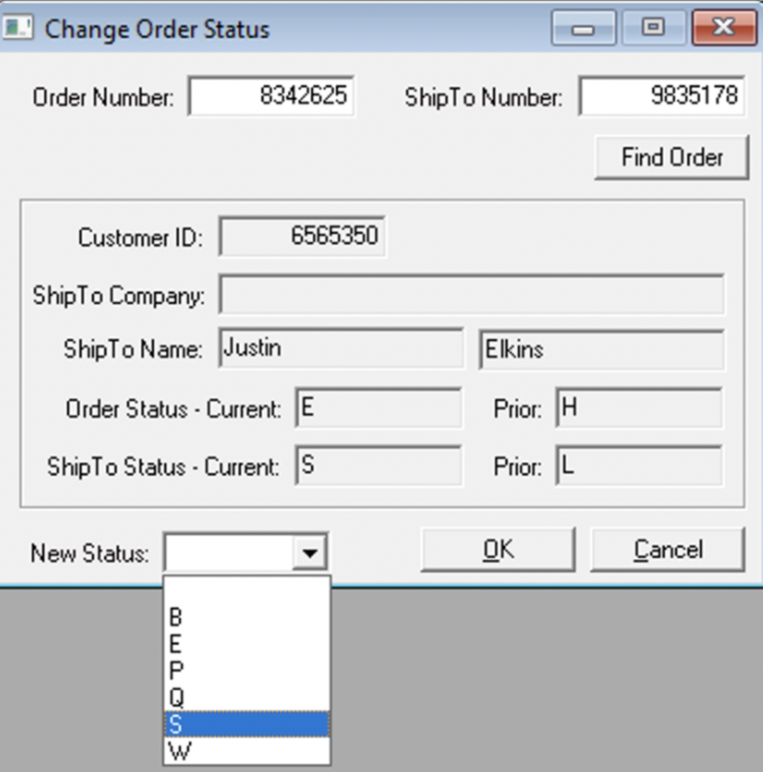

1. Orders > Supervisor Options > Change Order Status

* Note: We removed this permission from almost everyone in Response because people weren't making sure that all lines were S.
* Here’s what the above order looks like in this window: